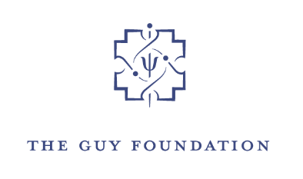

**PRESS RELEASE**

**GEORGE FREEMAN MP JOINS GUY FOUNDATION SPACE HEALTH PROJECT**

EMBARGO: NOT FOR RELEASE BEFORE 00.01 HRS 18th March 2025

**George Freeman MP, former UK Minister for Space and Life Science has joined The Guy Foundation as International Special Advisor to coordinate its work on space health. His appointment follows the publication of The Foundation’s report on health hazards arising from quantum effects during space travel. The report details how changes in magnetic fields, the light spectrum, gravity and radiation significantly impact space travellers’ mitochondria and disrupt their cellular bioenergetics. These harmful effects are expected to get worse the further humans travel from Earth and may be difficult or impossible to reverse.**

George Freeman was elected to the UK Parliament in 2010 after a 15-year career in science and technology venture finance. As a Minister for Life Science and Minister of State at the Department for Science, Innovation and Technology, he has played an influential role in UK science policy and diplomacy for the last 15 years.  Re-elected in 2024, he is Chair of the All-Party Parliamentary and Scientific Committee and has recently been appointed a UK Trade Envoy by the Prime Minister.

With the support of The Guy Foundation’s Space Health Working Group, he will lead the Foundation’s discussions with space agencies and space companies with a view to establishing and building research collaborations. The initial focus will be on magnetic fields and the altered light spectrum. In time, The Foundation will look to develop appropriate standards and protocols.

George Freeman said, *“Quantum biology – the appliance of the science of how quantum mechanics affects the function of biological systems - is rapidly becoming one of the new frontiers of human health, and I am delighted to be supporting The Guy Foundation in taking this important work forward. More work is urgently needed to better investigate and understand the effects of space on health. It is urgently needed with respect to improving astronaut health and also harnessing space as the new frontier for life and health science.*

Professor Geoffrey Guy, Founder and Chairman of The Guy Foundation, said *“We are delighted to welcome George as an Advisor to The Guy Foundation. We look forward to working with him as we build a global consortium on space health. His help will be invaluable as we broaden understanding of the potential benefits of quantum biology for human wellbeing in space and on Earth.”*

Almost all space exploration to date has taken place in low-Earth orbit (below an altitude of 1,200 miles). The International Space Station orbits at an average altitude of only 250 miles, and very few of the 700 or so astronauts who have been to space have ventured beyond this horizon.

The Guy Foundation believes that plans to go to the Moon, Mars and further into deep space, will need to factor in dramatic changes to the quantum environment, particularly the loss of the Earth's magnetic field, in order for astronauts to avoid the potentially severe health hazards in such environments.

**Notes to Editors**

**The Guy Foundation** is a UK-based charitable foundation (charity no 1178782) established in 2018 to facilitate thinking and research on the role of quantum mechanics and thermodynamics in living systems, with the ultimate goal of using this understanding to advance healthcare. The Foundation curates, leads and funds an inter-disciplinary research collaboration and has published a number of scientific papers. It supports the quantum biology community by convening online symposia on quantum biology and bioenergetics and it hosts an active network of over 300 scientists and institutions across the globe.

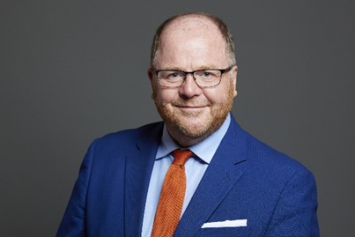

**George Freeman MP** has held a number of key Science & Technology Ministerial roles over the last 15 years: as first UK Minister for Life Science, first Minister for Decarbonisation & Digitalisation of Transport and Minister of State for Science & Technology shaping the UK’s programs for Quantum, Fusion, Space and EngBio. As Minister for Life Science he led the UK’s Life Science Industrial Strategy launching Genomics England, the Dementia Research Institute & the Accelerated Access reforms. As Minister for Space at the Department of Science, Innovation & Technology, George was responsible for the UK space sector, UK membership of ESA, and UK regulatory leadership in space sustainability through the Government’s establishment of the ESSI standards project for which he secured backing from international space agencies. George was also responsible for the UK’s ten year £2.5bn UK Quantum program and the focus on quantum moonshots to crowd in private sector co-investment. George has represented the UK at successive G7 & G20 Science Summits, in 2023 he oversaw the UK’s renegotiation to the European Horizon R+D and negotiated the UK’s Science + Technology Collaborations with Canada, Japan, Israel & Switzerland. George currently serves as Chair of the All Party Science in Parliament Committee and in 2025 he was appointed as UK Trade Envoy to Malaysia, Philippines, Singapore & Brunei.

**Professor Geoffrey Guy** is Founder and Chairman of The Guy Foundation. Professor Guy, a physician, has 40 years’ experience in medical research and global drug development. He founded the drug delivery company Ethical Holdings plc in 1985 and led the company to its NASDAQ listing in 1993; in 1989 he founded Phytopharm plc, of which he was Chairman until 1997; in 1998 he founded GW Pharmaceuticals plc, a world leader in cannabinoid therapeutics, and was Chairman until its sale in May 2021. He has been the physician in charge of over 300 clinical studies and is the author of over 80 scientific publications.

**‘The Health Hazards of Space Travel: novel insights from quantum biology’ report** is available at https://www.theguyfoundation.org/space-health/.

*For further information, please contact:*

Mark Rogerson, Press & PR, The Guy Foundation

press@theguyfoundation.org

+44 7885 638810